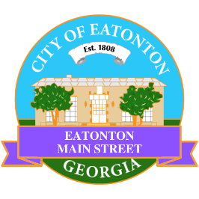

Eatonton Main Street
Advisory Board Meeting Agenda
August 9, 2022

Eatonton Main Street's Mission Statement:
To preserve and to enhance the historical and the cultural character of Eatonton through economic development.

Eatonton Main Street's Vision Statement:
Eatonton Main Street will be thriving and beautiful, rich in culture and heritage, sustained by community support.

- Call to Order

- Welcome
  - EQ Check-In
  - Approval of the Minutes from the July Meeting
  - Financial Report

- Old Business
  - Downtown Mural
  - Review of Rise & Shine Meeting

- New Business
  - Wayfinding Signage
  - Manager Update
    - Property Updates
    - Volunteers for Makers & Music
    - New Board Officers
    - September Meeting Date

- Façade Grants
  - Nails By Aaron

- Board News & Announcements
  - Makers & Music with Kasper & The 911 Band on Saturday, August 13th; Vendors open at 5:00pm and the concert begins at 7:00pm
  - Downtown Open: A Mini Golf Event on Saturday, September 10th from 4:00pm until 8:00pm
  - Business Education Expo (BEE), Day 1 at the Chamber on Tuesday, September 13th from 6:00pm until 8:00pm
  - Business Education Expo (BEE), Day 2 at the Chamber on Tuesday, September 20th from 6:00pm until 8:00pm
- Adjournment

Next Meeting: September TBD | 6:00pm | The Hut

