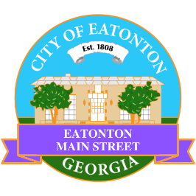

Eatonton Main Street
Advisory Board Meeting Agenda
July 8, 2025

Eatonton Main Street's Mission Statement:
To preserve and to enhance the historical and the cultural character of Eatonton through economic development.

Eatonton Main Street's Vision Statement:
Eatonton Main Street will be thriving and beautiful, rich in culture and heritage, sustained by community support.

- Call to Order

- Welcome
  - EQ Check-In
  - Approval of the Minutes from the June meeting
  - Financial Report

- Old Business
  - Review of the Workplan
  - Farmer’s Market
  - SWOT Analysis

- New Business
  - City Council Presentation
  - Manager Report
    - Christmas Open House
    - Board Members’ Training
    - Property Updates:
      - 117 N. Jefferson Avenue (The Rabbit’s Hole building) is for sale for $695,000; down from $750,000
      - 201 E. Sumter Street sold for $195,000
      - Flawless Apparel & Customs has moved out of 115 S. Jefferson Avenue
      - 115 & 117 S. Jefferson Avenue are under contract (asking price $450,000)
      - 111 & 113 N. Madison Avenue sold for $435,000
      - 204 S. Jefferson Avenue is for sale for $467,000
      - 321 S. Jefferson Avenue (the Dairy building) is for sale for $679,000; down from $699,000
      - Updates regarding 113 E. Marion Street (the former Lumberjaxe building)
- Façade Grants
  - None at this time

- Board News & Announcements
  - Downtown GetDown Concert on July 12th at the Eatonton City Center Stage. Vendors open at 6:00pm and the music starts at 7:00pm. Band: The Bourbon Brothers (Music of Frank Sinatra)
    - 1 volunteer will be needed for the Band Hospitality at City Hall from 5:00pm until 8:30pm
  - Walking Audit on July 22nd at 6:00pm at the Chamber of Commerce
  - Farmer’s Market on Friday, July 25th from 5:00pm until 8:00pm

- Adjournment

Next Meeting: August 12, 2025 | 6:00pm | The Hut

