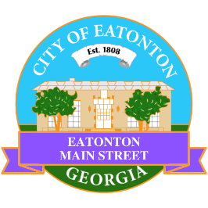

Eatonton Main Street
Advisory Board Meeting Agenda
June 11, 2024

Eatonton Main Street's Mission Statement:
To preserve and to enhance the historical and the cultural character of Eatonton through economic development.

Eatonton Main Street's Vision Statement:
Eatonton Main Street will be thriving and beautiful, rich in culture and heritage, sustained by community support.

- Call to Order

- Welcome
  - EQ Check-In
  - Approval of the Minutes from the May meeting
  - Financial Report
  - SWOT Analysis

- Old Business
  - Review of the Workplan
    - Business Pop-Up
  - Update on Business Visits
  - The Georgia Trust’s Expedition

- New Business
  - Rise & Shine in July
  - Manager Report
    - Event Recap: Dairy Festival and June Concert
    - An Evening in Eatonton
    - Property Updates

- Façade Grants
  - Maggie Lane

- Board News & Announcements
  - Juneteenth is Wednesday, June 19th; All City of Eatonton offices will be closed.
  - An Evening in Eatonton on Thursday, June 27th from 5:00pm until 8:00pm
  - Next Downtown GetDown Concert will take place on Saturday, July 13th with Jay Wingfield and The Blaq Berry Band

- Adjournment

Next Meeting: July 9, 2024 | 6:00pm | The Hut

