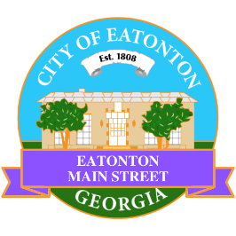

Eatonton Main Street
Advisory Board Meeting Agenda
February 10, 2026

Eatonton Main Street's Mission Statement:
To preserve and to enhance the historical and the cultural character of Eatonton through economic development.

Eatonton Main Street's Vision Statement:
Eatonton Main Street will be thriving and beautiful, rich in culture and heritage, sustained by community support.

- Call to Order

- Welcome
  - EQ Check-In
  - Approval of the Minutes from the January Retreat
  - Financial Report

- Old Business
  - Review of the Workplan
    - Creation of Committees

- New Business
  - Elect a New Board Secretary
  - 2026 Field Trip
  - Manager Report
    - #LoveLocal Letters
    - Property Updates
      - 107 N. Jefferson Avenue is available for rent for $3500 per month
      - 112 S. Madison Avenue is for sale for $432,000
      - Home Again opened at 108 N. Jefferson Avenue
      - The price on the old Dairy Building at 321 S. Jefferson Avenue increased to $899,000
      - Sassy Nails of Eatonton will open at 117 S. Jefferson Avenue at the beginning of March

- Façade Grants
  - None at this time

- Board News & Announcements
  - Next Accountability Call on Tuesday, February 24th at 6:30pm
  - Seuss on the Loose on Saturday, March 7th at 9:00am at the Primary School (1-2 Volunteers needed)
  - Business Education Expo (BEE) on Tuesday, March 17th at 6:00pm at the Chamber of Commerce

- Adjournment

Next Meeting: March 10, 2026 | 6:00pm | The Hut

