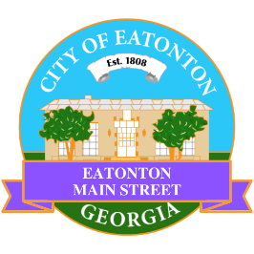

Eatonton Main Street
Advisory Board Meeting Agenda
August 6, 2024

Eatonton Main Street's Mission Statement:
To preserve and to enhance the historical and the cultural character of Eatonton through economic development.

Eatonton Main Street's Vision Statement:
Eatonton Main Street will be thriving and beautiful, rich in culture and heritage, sustained by community support.

- Call to Order

- Welcome
  - EQ Check-In
  - Approval of the Minutes from the July meeting
  - Financial Report

- Old Business
  - Review of the Workplan
  - Update on Business Visits
  - Review of the Rise & Shine Meeting
  - The Eatonton Expedition

- New Business
  - SPLOST 10
  - Manager Report
    - Upcoming events: An Evening in Eatonton & Scarecrow Contest & Showcase
    - El Cazador Mexican Restaurant
    - Property Updates
      - Tasty Wings & Seafood opened on August 5th
      - Matt & Cathy Roundtree are the new owners of Holloway’s Ace Hardware
      - 321 S. Jefferson Ave. (the old Creamery) has been taken off of the market
      - The listing price for 101 N. Washington Ave. (the old Jail) has gone down $50,000 to $349,000
      - 100 N. Madison Ave. is for sale for $250,000
      - One of the Blackwell buildings is under contract with Red Dog Creative

- Façade Grants
  - None at this time

- Board News & Announcements
  - Next Downtown GetDown Concert will take place on Saturday, August 10th with John Dunn & the Jazzman Band and Dynamic Sounds of Phunk
    - 2 volunteers to help with band hospitality from 5:00pm-8:00pm
  - Bag stuffing for The Expedition at The Plaza on Friday, August 16th; Time TBA
  - The Expedition at The Plaza on Saturday, August 17th from 8:30am-11:30am
  - Next Accountability Call is Tuesday, August 27th at 6:30pm

- Adjournment

Next Meeting: September 10, 2024 | 6:00pm | The Hut

