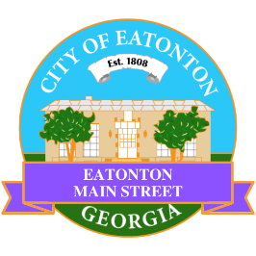

Eatonton Main Street
Advisory Board Meeting Agenda
May 6, 2025

Eatonton Main Street's Mission Statement:
To preserve and to enhance the historical and the cultural character of Eatonton through economic development.

Eatonton Main Street's Vision Statement:
Eatonton Main Street will be thriving and beautiful, rich in culture and heritage, sustained by community support.

- Call to Order

- Welcome
  - EQ Check-In
  - Approval of the Minutes from the April meeting
  - Financial Report

- Old Business
  - Review of the Workplan
    - Meetings with City Councilmembers
  - Review of the Rise & Shine Meeting
  - Farmer’s Market

- New Business
  - Committees
  - Your City is Sick
  - Manager Report
    - BBQ & Blues Festival
    - Commercial Realtor Open House
    - Dairy Festival

- Façade Grants
  - None at this time

- Board News & Announcements
  - Memorial Day is Monday, May 26th; All City of Eatonton offices will be closed.
  - Accountability Call on Tuesday, May 27th at 6:30pm
  - Dairy Festival on Saturday, June 7th from 9:00am until 5:00pm
  - Downtown GetDown Concert on June 14th at the Eatonton City Center Stage. Vendors open at 6:00pm and the music starts at 7:00pm. Band: Derrick Dove & the Peacekeepers (Southern Fried Rock)
    - 1-2 volunteers will be needed for the Band Hospitality at City Hall from 5:00pm until 8:30pm
  - Juneteenth is Thursday, June 19th; All City of Eatonton offices will be closed.
  - An Evening in Eatonton on Thursday, June 26th from 5:00pm until 8:00pm
  - Don’t forget your training!
    - https://www.youtube.com/@gamainst/videos
    - https://www.youtube.com/@NationalMainStreet/videos

- Adjournment

Next Meeting: June 10, 2025 | 6:00pm | The Hut

