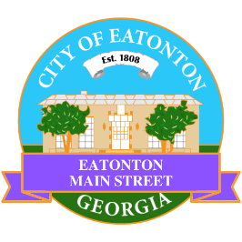

Eatonton Main Street
Advisory Board Meeting Agenda
December 13, 2022

Eatonton Main Street's Mission Statement:
To preserve and to enhance the historical and the cultural character of Eatonton through economic development.

Eatonton Main Street's Vision Statement:
Eatonton Main Street will be thriving and beautiful, rich in culture and heritage, sustained by community support.

- Call to Order

- Welcome
  - EQ Check-In
  - Approval of the Minutes from the November Meeting
  - Financial Report

- Old Business
  - Update on Wayfinding Signage
  - Update on Downtown Mural
  - Update on Board Vacancies

- New Business
  - 2023 Meeting Schedule
  - Review of 2022

- Façade Grants
  - None at this time

- Board News & Announcements
  - No Accountability Call for December
- Adjournment

Next Meeting: January 10, 2023 | 9:00am | Eatonton-Putnam Chamber of Commerce

