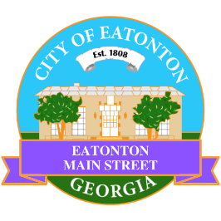

Eatonton Main Street
Advisory Board Meeting Agenda
November 8, 2022

Eatonton Main Street's Mission Statement:
To preserve and to enhance the historical and the cultural character of Eatonton through economic development.

Eatonton Main Street's Vision Statement:
Eatonton Main Street will be thriving and beautiful, rich in culture and heritage, sustained by community support.

- Call to Order

- Welcome
  - EQ Check-In
  - Approval of the Minutes from the September & October Meeting
  - Financial Report

- Old Business
  - Update on Wayfinding Signage
  - Update on Downtown Mural

- New Business
  - Board Retreat—January 10, 2023
  - Manager Update
    - Scarecrow Contest
    - Mistletoe Market
    - Christmas Parade
    - Property Updates

- Façade Grants
  - None at this time

- Board News & Announcements
  - Mistletoe Market on Saturday, November 12th on the Courthouse Lawn (Setup at 7:45am)
  - Accountability Call on Tuesday, November 22nd at 6:30pm
  - Small Business Saturday is November 26th
  - Christmas Parade on Saturday, December 10th at 1:00pm
  - Christmas Parade After Party on Saturday, December 10th at 2:00pm at the Eatonton City Center Stage
- Adjournment

Next Meeting: December 13, 2022 | 6:00pm | The Hut

