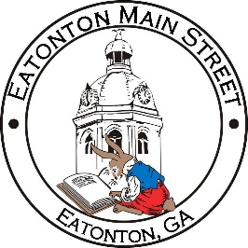

Eatonton Main Street
Advisory Board Meeting Agenda
July 12, 2022

Eatonton Main Street's Mission Statement:
To preserve and to enhance the historical and the cultural character of Eatonton through economic development.

Eatonton Main Street's Vision Statement:
Eatonton Main Street will be thriving and beautiful, rich in culture and heritage, sustained by community support.

- Call to Order

- Welcome
  - EQ Check-In
  - Approval of the Minutes from the June Meeting
  - Financial Report

- Old Business
  - New Main Street Logo

- New Business
  - Review of Annual Work Plan
  - Manager Update
    - Property Updates
    - Review of Makers & Movies

- Façade Grants
  - Peaceful Purpose Hospice of Georgia
  - Maggie Lane

- Board News & Announcements
  - Rise & Shine Meeting on Tuesday, July 26th at 6:30pm at El Cazador
  - Makers & Music with Kasper & The 911 Band on Saturday, August 13th
- Adjournment

Next Meeting: August 9, 2022 | 6:00pm | The Hut

