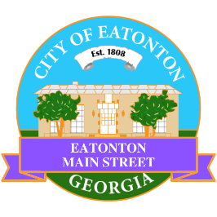

Eatonton Main Street
Advisory Board Meeting Agenda
October 10, 2023

Eatonton Main Street's Mission Statement:
To preserve and to enhance the historical and the cultural character of Eatonton through economic development.

Eatonton Main Street's Vision Statement:
Eatonton Main Street will be thriving and beautiful, rich in culture and heritage, sustained by community support.

- Call to Order

- Welcome
  - EQ Check-In
  - Approval of the Minutes from the September Meeting
  - Financial Report

- Old Business
  - Next Rise & Shine Meeting
  - Advisory Board Terms
  - Façade Grant from Taylor Event & Floral Design

- New Business
  - 2024 Board Retreat (January 14, 2024)
  - 2024 Events
  - Manager Report:
    - Scarecrow Contest
    - Hispanic Heritage Month
    - Mistletoe Market
    - Property Update: 108 N. Madison Ave. sold for $60,000 (listing price was $65,000)

- Façade Grants
  - Sylvia’s

- Board News & Announcements
  - Grand Opening for Merrily Monroe Boutique (201 E. Sumter Street)
  - ¡Bailamos! On Saturday, October 14th from 4:00pm until 7:00pm at the Eatonton City Center Stage
  - Next Accountability Call on Tuesday, October 24th at 6:30pm
  - Lunch Break Day Party on Friday, October 27th from 11:00am until 1:00pm at the Eatonton City Center Stage
  - Mistletoe Market on Saturday, November 11th from 10:00am until 3:00pm on the lawn of the Putnam County Courthouse
  - Don’t forget about your required training: www.GeorgiaMainStreet.org
    - Main Street 101 is $75.
    - Switch to Six Webinar is free!
    - Deadline: December 31st
- Adjournment

Next Meeting: November 14, 2023 | 6:00pm | The Hut

