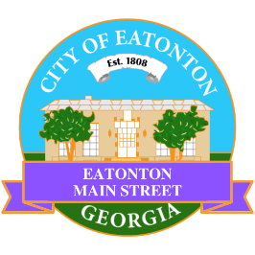

Eatonton Main Street
Advisory Board Meeting Agenda
February 11, 2025

Eatonton Main Street's Mission Statement:
To preserve and to enhance the historical and the cultural character of Eatonton through economic development.

Eatonton Main Street's Vision Statement:
Eatonton Main Street will be thriving and beautiful, rich in culture and heritage, sustained by community support.

- Call to Order

- Welcome
  - EQ Check-In
  - Approval of the Minutes from the January Retreat
  - Financial Report

- Old Business
  - Review of the Rise & Shine Meeting
    - Review of Workplan

- New Business
  - Adopt-A-Planter
  - Manager Report
    - #LoveLocal Letters
    - Property Updates
      - 125 S. Jefferson Avenue (formerly Nina’s Beauty Supply) is for sale for $349,900, which is a decrease from $399,000
      - 321 S. Jefferson Avenue (the Dairy Building) is for rent for $6,000 in addition to being for sale
      - 115-117 S. Jefferson Avenue decreased the sale price down to $450,000 (former price was $550,000)
      - 207 N. Jefferson Avenue decreased the sale price down to $339,000 (former price was $350,000)
      - Luxe Braid Bar will be closing at the end of February at 108 N. Jefferson Avenue
      - Merrily Monroe Boutique and All Southern Industrial Supply will be closing at 201 E. Sumter Street on April 21, 2025

- Façade Grants
  - None at this time

- Board News & Announcements
  - Next Accountability Call on Tuesday, February 25th at 6:30pm
  - Seuss on the Loose on Saturday, March 1st at 9:00am at the Elementary School
  - Grand opening of SIPS 31024 on Saturday, March 1st
  - Business Education Expo (BEE) on Tuesday, March 11th at 6:00pm at the Chamber of Commerce
  - Don’t forget your 2 hours of training!

- Adjournment

Next Meeting: March 4, 2025 | 6:00pm | The Hut

