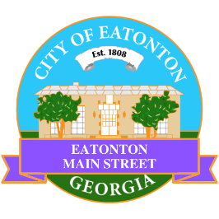

Eatonton Main Street
Advisory Board Meeting Agenda
June 10, 2025

Eatonton Main Street's Mission Statement:
To preserve and to enhance the historical and the cultural character of Eatonton through economic development.

Eatonton Main Street's Vision Statement:
Eatonton Main Street will be thriving and beautiful, rich in culture and heritage, sustained by community support.

- Call to Order

- Welcome
  - EQ Check-In
  - Approval of the Minutes from the May meeting
  - Financial Report

- Old Business
  - Review of the Workplan
  - Your City Is Sick

- New Business
  - SWOT Analysis
  - Manager Report
    - Walking Audit on July 22nd
    - Property Updates:
      - 201 E. Sumter Street is under contract (asking price is $205,000)
      - 117 N. Jefferson Avenue is for sale for $750,000
      - 105 S. Jefferson Avenue is for sale for $349,000
      - 113 S. Jefferson Avenue has been rented by Make Craft Fun Club (Opening July 7)
      - 125 S. Jefferson Avenue is under contract (asking price $325,000)
      - 100 N. Madison Avenue sold for $170,000 (asking price was $250,000)
      - 108 N. Madison Avenue sold for $70,000
      - Maxway is closing and will be closed by August

- Façade Grants
  - None at this time

- Board News & Announcements
  - Downtown GetDown Concert on June 14th at the Eatonton City Center Stage. Vendors open at 6:00pm and the music starts at 7:00pm. Band: Derrick Dove & the Peacekeepers (Southern Fried Rock)
    - 1-2 volunteers will be needed for the Band Hospitality at City Hall from 5:00pm until 8:30pm
  - Juneteenth is Thursday, June 19th; All City of Eatonton offices will be closed.
  - An Evening in Eatonton on Thursday, June 26th from 5:00pm until 8:00pm
  - Don’t forget your training!
    - https://www.youtube.com/@gamainst/videos
    - https://www.youtube.com/@NationalMainStreet/videos

- Adjournment

Next Meeting: July 8, 2025 | 6:00pm | The Hut

