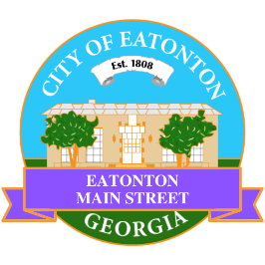

Eatonton Main Street
Advisory Board Meeting Agenda
September 9, 2025

Eatonton Main Street's Mission Statement:
To preserve and to enhance the historical and the cultural character of Eatonton through economic development.

Eatonton Main Street's Vision Statement:
Eatonton Main Street will be thriving and beautiful, rich in culture and heritage, sustained by community support.

- Call to Order

- Welcome
  - EQ Check-In
  - Approval of the Minutes from the August meeting
  - Financial Report

- Old Business
  - Review of the Workplan
  - Pedestrian Wayfinding Signage

- New Business
  - 2025-2026 Budget
  - Rise & Shine Meeting—October
  - Manager Report
    - Event Updates
    - Property Updates—None at this time
- Façade Grants
  - None at this time

- Board News & Announcements
  - Next Downtown GetDown Concert will take place on Saturday, September 13th with The Atlanta Jazz Players
    - 1 volunteer to help with band hospitality from 5:00pm-7:30pm
  - Registration ends September 23rd for the Scarecrow Contest
  - Next Accountability Call is Tuesday, September 23rd at 6:30pm
  - An Evening in Eatonton is Thursday, September 25th from 4:00pm until 7:00pm
  - Downtown Eatonton Farmer’s Market is Friday, September 26th from 5:00pm until 8:00pm
  - Taste of Eatonton is Monday, October 6th from 5:00pm until 8:00pm at The Plaza Arts Center
  - SAVE THE DATE: Eatonton Mistletoe Market on Saturday, November 8th
  - SAVE THE DATE: Christmas in Eatonton on Saturday, December 13th

- Adjournment

Next Meeting: October 14, 2025 | 6:00pm | The Hut

