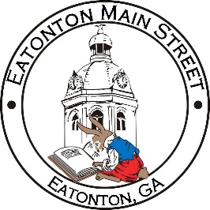

Eatonton Main Street
Advisory Board Meeting Agenda
June 14, 2022

Eatonton Main Street's Mission Statement:
To preserve and to enhance the historical and the cultural character of Eatonton through economic development.

Eatonton Main Street's Vision Statement:
Eatonton Main Street will be thriving and beautiful, rich in culture and heritage, sustained by community support.

- Call to Order

- Welcome
  - EQ Check-In
  - Approval of the Minutes from the May Meeting
  - Financial Report

- Old Business
  - Downtown Mural
  - Rise & Shine Meetings

- New Business
  - Downtown Clean Up Day
  - Manager Update
    - Property Updates
    - Review of the Dairy Festival and Makers & Movies
    - Surprise!

- Façade Grants
  - None at this time

- Board News & Announcements
  - Employee & Volunteer Appreciation Luncheon at The Hut on Tuesday, June 28th from 11:00am-1:00pm
  - Accountability Call on Tuesday, June 28th at 6:30pm
  - Makers & Movies—Christmas in July on Saturday, July 9th featuring the movie “This Christmas”
- Adjournment

Next Meeting: July 12, 2022 | 6:00pm | The Hut

