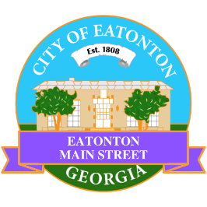

Eatonton Main Street
Advisory Board Meeting Agenda
April 15, 2025

Eatonton Main Street's Mission Statement:
To preserve and to enhance the historical and the cultural character of Eatonton through economic development.

Eatonton Main Street's Vision Statement:
Eatonton Main Street will be thriving and beautiful, rich in culture and heritage, sustained by community support.

- Call to Order

- Welcome
  - EQ Check-In
  - Approval of the Minutes from the March meeting
  - Financial Report

- Shannon’s Report

- Old Business
  - Review of the Workplan
  - Update on Business Visits
  - Adopt-A-Planter Program

- New Business
  - Christmas Open House
  - An Evening in Eatonton/Farmer’s Market
  - 2025-2026 Budget
  - May’s Advisory Board Meeting
  - Manager Report
    - Magnolia Market & Chalk Walk
    - BBQ & Blues Festival
    - Property Updates
    - Accreditation Update

- Façade Grants
  - None at this time

- Board News & Announcements
  - Day Party Celebrating Eatonton on Friday, April 25th from 11:00am until 2:00pm at the Eatonton City Center Stage
  - BBQ & Blues Festival on Saturday, May 3rd from 2:00pm-10:00pm
    - 2-3 Volunteers will be needed to help load in vendors from 11:00am-2:00pm
    - 1-2 volunteers will be needed to help with the VIP parking from 12:00pm-4:00pm
    - 1 Volunteer will be needed to help with the VIP & Hospitality Area
    - Any amount of volunteers will be needed to help clean up from 8:30pm until ?
    - 1 Volunteer will be needed on Friday, May 2nd to help set up

- Adjournment

Next Meeting: May 6, 2025 | 6:00pm | The Hut

