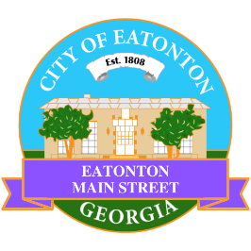

Eatonton Main Street
Advisory Board Meeting Agenda
April 11, 2023

Eatonton Main Street's Mission Statement:
To preserve and to enhance the historical and the cultural character of Eatonton through economic development.

Eatonton Main Street's Vision Statement:
Eatonton Main Street will be thriving and beautiful, rich in culture and heritage, sustained by community support.

- Call to Order

- Welcome
  - EQ Check-In
  - Approval of the Minutes from the March Meeting
  - Financial Report

- Old Business
  - Business Education Expo
  - Downtown Mural

- New Business
  - Hispanic Heritage Month (September 15-October 15)
  - El Cazador Mexican Restaurant
  - Manager Report:
    - Magnolia Market & Chalk Walk
    - BBQ & Blues Festival
    - Property Update

- Façade Grants
  - Smiles By Oliver (d/b/a Most Valuable Smiles)

- Board News & Announcements
  - Magnolia Market & Chalk Walk on Saturday, April 22nd from 10:00am until 3:00pm
  - Accountability Call on Tuesday, April 25th at 6:30pm
  - Day Party Celebrating Eatonton on Wednesday, April 26th from 11:00am until 2:00pm
  - BBQ & Blues Festival on Saturday, May 6th from 2:00pm until 10:00pm
  - Don’t forget about your required training: www.GeorgiaMainStreet.org
    - Main Street 101 is $50 until May 1st. After May 1st, Main Street 101 is $75.
    - Switch to Six Webinar is free!
- Adjournment

Next Meeting: May 9, 2023 | 6:00pm | The Hut

