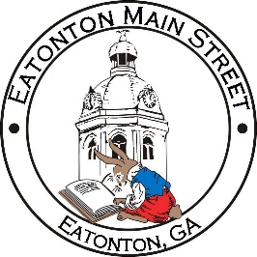

Eatonton Main Street
Advisory Board Meeting Agenda
June 8, 2021

Eatonton Main Street's Mission Statement:
To preserve and to enhance the historical and the cultural character of Eatonton through economic development.

Eatonton Main Street's Vision Statement:
Eatonton Main Street will be thriving and beautiful, rich in culture and heritage, sustained by community support.

- Call to Order

- Welcome
  - EQ Check-In
  - Team Exercise
  - Approval of the Minutes from May Meeting
  - Financial Report

- Old Business
  - Board Vacancy Update
  - Arts & Entertainment District

- New Business
  - Committee Updates
    - Work Plan 6-month check in
    - What’s next?
  - July Meeting

- Façade Grants
  - None at this time

- Board News & Announcements
  - Main Street 101 at www.GeorgiaMainStreet.org under “Training”
  - Happy Nails (101 S. Oak Street) is open with new management and new owners
  - 104 W. Marion Street (next to Papa John’s) is under contract
  - Movies & Makers on Saturday, June 12th
  - Movies & Makers on Saturday, July 10th
  - Business Education Expo at the Chamber on July 13, 20, 27 from 6:00pm-8:00pm each night
  - Downtown BASH on Thursday, July 29th at 5:30pm (Location TBD)

- Adjournment

Next Meeting: July 2021 | 6:00pm | The Hut

