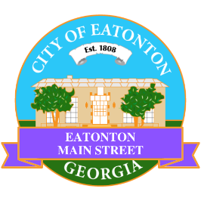

Eatonton Main Street
Advisory Board Meeting Agenda
May 12, 2026

Eatonton Main Street's Mission Statement:
To preserve and to enhance the historical and the cultural character of Eatonton through economic development.

Eatonton Main Street's Vision Statement:
Eatonton Main Street will be thriving and beautiful, rich in culture and heritage, sustained by community support.

- Call to Order

- Welcome
  - EQ Check-In
  - Approval of the Minutes from the April meeting
  - Financial Report

- Old Business
  - Review of the Workplan
  - Field Trip to Lawrenceville

- New Business
  - Volunteers
  - Manager Report
    - BBQ & Blues Festival
    - Property Updates
      - 207 N. Jefferson Avenue sold for $260,000 (asking price was $310,000)
      - 403 W. Marion Street sold for $101,508
      - 112 S. Madison Avenue sold
      - 117 N. Jefferson Avenue is no longer on the market
- Façade Grants
  - Sassy Nails (117 S. Jefferson Avenue)
  - Georgia Writers Museum (109 S. Jefferson Avenue)
  - Georgia Writers Museum (111 S. Jefferson Avenue)
  - Georgia Writers Museum (113 S. Jefferson Avenue)

- Board News & Announcements
  - Downtown Eatonton Farmer’s Market on Friday, May 22nd from 5:00pm until 8:00pm
  - All City of Eatonton Offices will be closed on Monday, May 25th for Memorial Day
  - Accountability Call on Tuesday, May 26th at 6:30pm
  - Dairy Festival on Saturday, June 6th from 9:00am until 4:00pm

- Adjournment

Next Meeting: June 9, 2026 | 6:00pm | The Hut

