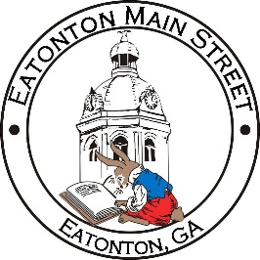

Eatonton Main Street
Advisory Board Meeting Agenda
March 8, 2022

Eatonton Main Street's Mission Statement:
To preserve and to enhance the historical and the cultural character of Eatonton through economic development.

Eatonton Main Street's Vision Statement:
Eatonton Main Street will be thriving and beautiful, rich in culture and heritage, sustained by community support.

- Call to Order

- Welcome
  - EQ Check-In
  - Approval of the Minutes from the February Meeting
  - Financial Report

- Old Business
  - Updates on Projects
  - Board Vacancy

- New Business
  - Meeting with Government Officials
  - Manager Update
    - Upcoming Events
    - Property Updates

- Façade Grants
  - Georgia Writers Museum

- Board News & Announcements
  - Business Education Expo (BEE) on March 15th and March 22nd at the Chamber
  - Accountability Call moved to Thursday, March 24th due to the BEE

- Adjournment

Next Meeting: April 12, 2022 | 6:00pm | The Hut

