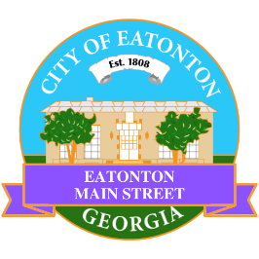

Eatonton Main Street
Advisory Board Retreat Agenda
January 9, 2024

Eatonton Main Street's Mission Statement:
To preserve and to enhance the historical and the cultural character of Eatonton through economic development.

Eatonton Main Street's Vision Statement:
Eatonton Main Street will be thriving and beautiful, rich in culture and heritage, sustained by community support.

- Call to Order

- Welcome
  - EQ Check-In
  - Approval of the Minutes from December Meeting
  - Financial Report

- Façade Grants
  - None at this time

- Annual Board Retreat

- Board News & Announcements
  - HEART Squad Orientation at 6:00pm at The Hut
    - Thursday, January 11
    - Thursday, January 18
  - Rise & Shine…in Prime Time Potluck Dinner on Tuesday, January 23 at 6:30pm at The Hut

- Adjournment

Next Meeting: February 13, 2024 | 6:00pm | The Hut

