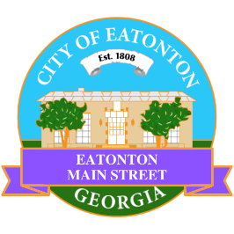

Eatonton Main Street
Advisory Board Meeting Agenda
May 9, 2023

Eatonton Main Street's Mission Statement:
To preserve and to enhance the historical and the cultural character of Eatonton through economic development.

Eatonton Main Street's Vision Statement:
Eatonton Main Street will be thriving and beautiful, rich in culture and heritage, sustained by community support.

- Call to Order

- Welcome
  - EQ Check-In
  - Approval of the Minutes from the April Meeting
  - Financial Report

- Old Business
  - Downtown Mural
  - Board Training

- New Business
  - 2023-24 Budget
  - Next Rise & Shine Meeting
  - Manager Report:
    - Magnolia Market & Chalk Walk
    - BBQ & Blues Festival
    - Dairy Festival
    - Downtown GetDown Concert Series
    - Property Update

- Façade Grants
  - None at this time

- Board News & Announcements
  - Next Accountability Call is Tuesday, May 23rd at 6:30pm
  - Dairy Festival is June 3rd from 9:00am until 5:00pm
  - Downtown GetDown Concert Series is June 10th; Vendors open at 6:00pm, Concert at 7:00pm
  - Don’t forget about your required training: www.GeorgiaMainStreet.org
    - Main Street 101 is $75.
    - Switch to Six Webinar is free!
- Adjournment

Next Meeting: June 13, 2023 | 6:00pm | The Hut

