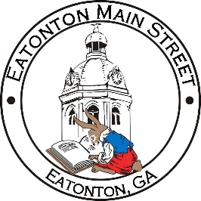

Eatonton Main Street
Advisory Board Meeting Agenda
September 16, 2021

Eatonton Main Street's Mission Statement:
To preserve and to enhance the historical and the cultural character of Eatonton through economic development.

Eatonton Main Street's Vision Statement:
Eatonton Main Street will be thriving and beautiful, rich in culture and heritage, sustained by community support.

- Call to Order

- Welcome
  - EQ Check-In
  - Approval of the Minutes from August Meeting
  - Financial Report

- Old Business
  - Update on Board Vacancy
  - Discussion of “Rise & Shine” Meeting

- New Business
  - Sumter Street Design Recommendations
  - Manager Update
    - America’s Main Street Contest
    - Scarecrow Contest
    - Property Updates

- Façade Grants
  - The FolksArt: Mercantile and Café
  - Ashley’s Tanning and Boutique
  - Eatonton Chiropractic Clinic

- Board News & Announcements
  - Main Street 101 at www.GeorgiaMainStreet.org under “Training” (Deadline: Oct. 31st)
  - Business Education Expo (BEE) on September 21st & 28th at the Chamber
  - Registration deadline for the Scarecrow Contest is September 23rd

- Adjournment

Next Meeting: October 12, 2021 | 6:00pm | The Hut

