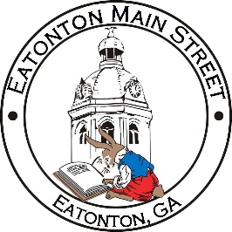

Eatonton Main Street
Advisory Board Meeting Agenda
November 9, 2021

Eatonton Main Street's Mission Statement:
To preserve and to enhance the historical and the cultural character of Eatonton through economic development.

Eatonton Main Street's Vision Statement:
Eatonton Main Street will be thriving and beautiful, rich in culture and heritage, sustained by community support.

- Call to Order

- Welcome
  - EQ Check-In
  - Team Exercise
  - Approval of the Minutes from October Meeting
  - Financial Report

- Old Business
  - Update on Board Vacancy
  - Update on Main Street Logo

- New Business
  - Board Retreat in January
  - Manager Update
    - America’s Main Street Contest
    - Scarecrow Contest
    - Property Updates
  - Momentum of the Main Street Program
    - Are we staying true to our Mission/Vision Statements?
    - How can we increase it? What are some factors slow us down? Life? Lack of volunteers? Meet more often?

- Façade Grants
  - None at this time.

- Board News & Announcements
  - Mistletoe Market on Saturday, November 13th—Volunteers needed.
  - Small Business Saturday on Saturday, November 27th
  - Rise & Shine Meeting on Saturday, December 4th at 9:00am at the Chamber

- Adjournment

Next Meeting: December 14, 2021 | 6:00pm | The Hut

