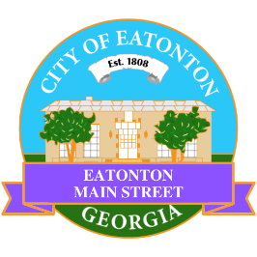

Eatonton Main Street
Advisory Board Meeting Agenda
July 11, 2023

Eatonton Main Street's Mission Statement:
To preserve and to enhance the historical and the cultural character of Eatonton through economic development.

Eatonton Main Street's Vision Statement:
Eatonton Main Street will be thriving and beautiful, rich in culture and heritage, sustained by community support.

- Call to Order

- Welcome
  - EQ Check-In
  - Approval of the Minutes from the June Meeting
  - Financial Report

- Old Business
  - Review of Rise & Shine Meeting
  - Hype Team

- New Business
  - Where is the love?
  - Manager Report:
    - Downtown GetDown Concert Series
    - Property Update
      - ReyFresh Beauty Salon closed at 105 S. Jefferson Avenue.
      - 105 S. Jefferson Avenue is for sale for $249,000
      - Sylvia’s coming soon!

- Façade Grants
  - LumberJaxe Axe Throwing Hall

- Board News & Announcements
  - Next Accountability Call is July 25th at 6:30pm
  - Downtown GetDown Concert Series is August 12th; Vendors open at 6:00pm, Concert at 7:00pm (2 volunteers will be needed.)
  - Don’t forget about your required training: www.GeorgiaMainStreet.org
    - Main Street 101 is $75.
    - Switch to Six Webinar is free!
- Adjournment

Next Meeting: August 8, 2023 | 6:00pm | The Hut

