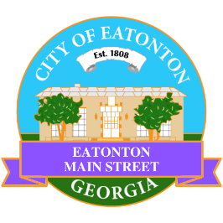

Eatonton Main Street
Advisory Board Meeting Agenda
March 12, 2024

Eatonton Main Street's Mission Statement:
To preserve and to enhance the historical and the cultural character of Eatonton through economic development.

Eatonton Main Street's Vision Statement:
Eatonton Main Street will be thriving and beautiful, rich in culture and heritage, sustained by community support.

- Call to Order

- Welcome
  - EQ Check-In
  - Approval of the Minutes from the February meeting
  - Financial Report

- Old Business
  - Field Trip
  - Review of the Workplan
  - Update on Business Visits

- New Business
  - Business Pop Up Day
  - Sculpture Trail
  - Manager Report
    - Business Education Expo
    - Magnolia Market & Chalk Walk
    - Property Updates: Lilac Lash Lounge opened at 103 E. Marion Street, Suite E

- Façade Grants
  - Pretty Girlz Fitness

- Board News & Announcements
  - Business Education Expo (BEE) on Thursday, March 14th at 6:00pm at the Chamber of Commerce
  - Next Accountability Call is Tuesday, March 26th at 6:30pm
  - City offices will be closed on Friday, March 29th for Good Friday
  - Magnolia Market & Chalk Walk on Saturday, April 13th from 10:00am until 3:00pm
    - Volunteers will be needed from 7:45am until 9:45am to help load in vendors

- Adjournment

Next Meeting: April 9, 2024 | 6:00pm | The Hut

