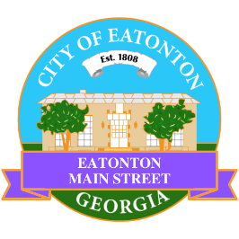

Eatonton Main Street
Advisory Board Retreat Agenda
January 10, 2023

Eatonton Main Street's Mission Statement:
To preserve and to enhance the historical and the cultural character of Eatonton through economic development.

Eatonton Main Street's Vision Statement:
Eatonton Main Street will be thriving and beautiful, rich in culture and heritage, sustained by community support.

- Call to Order

- Welcome
  - EQ Check-In
  - Approval of the Minutes from December Meeting
  - Financial Report

- Façade Grants
  - None at this time

- Annual Board Retreat
  - Welcome
  - Icebreaker
  - Power of Why
  - What do the surveys really say?
The Current Pillar Work
  - The Common Ground between the Surveys and the Pillar Work
  - The Board Members Strengths and Attributes
  - Where do we go from here?
  - The Connected Dots!

- Board News & Announcements
  - None at this time

- Adjournment

Next Meeting: February 14, 2023 | 6:00pm | The Hut

