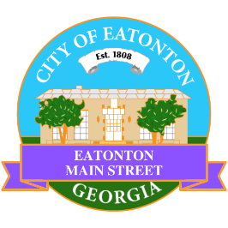

Eatonton Main Street
Advisory Board Meeting Agenda
March 14, 2023

Eatonton Main Street's Mission Statement:
To preserve and to enhance the historical and the cultural character of Eatonton through economic development.

Eatonton Main Street's Vision Statement:
Eatonton Main Street will be thriving and beautiful, rich in culture and heritage, sustained by community support.

- Call to Order

- Welcome
  - EQ Check-In
  - Approval of the Minutes from the February Meeting
  - Financial Report

- Old Business
  - Update on Board Vacancies
    - Board Secretary

- New Business
  - Review of Rise & Shine Meeting
  - Manager Report:
    - Magnolia Market & Chalk Walk
    - Property Update

- Façade Grants
  - None at this time

- Board News & Announcements
  - Business Education Expo at the Chamber of Commerce on March 21st at 6:00pm
  - National Main Street Conference in Boston is March 27-29
  - Next Accountability Call is Tuesday, March 28th at 6:30pm
  - Community Clean Up Day at City Hall on Saturday, April 1st from 9:00am until 12:00pm
  - Magnolia Market & Chalk Walk on Saturday, April 8th from 10:00am until 3:00pm
  - Don’t forget about your required training: www.GeorgiaMainStreet.org
    - Main Street 101 is $50 until May 1st. After May 1st, Main Street 101 is $75.
    - Switch to Six Webinar is free!
- Adjournment

Next Meeting: April 11, 2023 | 6:00pm | The Hut

