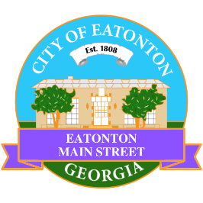

Eatonton Main Street
Advisory Board Meeting Agenda
February 13, 2024

Eatonton Main Street's Mission Statement:
To preserve and to enhance the historical and the cultural character of Eatonton through economic development.

Eatonton Main Street's Vision Statement:
Eatonton Main Street will be thriving and beautiful, rich in culture and heritage, sustained by community support.

- Call to Order

- Welcome
  - EQ Check-In
  - Approval of the Minutes from the January Retreat
  - Financial Report

- Old Business
  - Review of the Rise & Shine Meeting
    - Review of Workplan
  - Update on Business Visits

- New Business
  - Field Trip
  - Manager Report
    - #LoveLocal Letters
    - HEART Squad
    - Property Updates

- Façade Grants
  - Taylor Flowers & Gifts

- Board News & Announcements
  - Next Accountability Call on Tuesday, February 27th at 6:30pm
  - Seuss on the Loose on Saturday, March 2nd at 9:00am at the Elementary School
  - “Peg Leg” Howell’s birthday is March 5th
  - Business Education Expo (BEE) on Thursday, March 14th at 6:00pm at the Chamber of Commerce
  - Don’t forget your 2 hours of training!

- Adjournment

Next Meeting: March 12, 2024 | 6:00pm | The Hut

