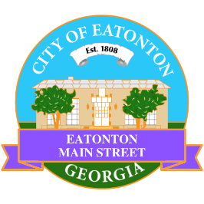

Eatonton Main Street
Advisory Board Meeting Agenda
December 9, 2025

Eatonton Main Street's Mission Statement:
To preserve and to enhance the historical and the cultural character of Eatonton through economic development.

Eatonton Main Street's Vision Statement:
Eatonton Main Street will be thriving and beautiful, rich in culture and heritage, sustained by community support.

- Call to Order

- Welcome
  - EQ Check-In
  - Approval of the Minutes from the November meeting
  - Financial Report

- Old Business
  - Review of the Workplan

- New Business
  - Visit from Georgia Main Street
  - Rise & Shine Meeting in January
  - Manager Report
    - 2026 Meetings
    - Holiday Open House
    - Property Updates
      - 110 N. Jefferson Avenue has been leased to an ice cream shop to open February/March
  - Review of 2025

- Façade Grants
  - None at this time

- Board News & Announcements
  - Due to the holidays, there will no Accountability Call in December
  - Christmas in Eatonton on Saturday, December 13th from 4:00pm until 8:00pm
    - 2-3 volunteers will be needed to help load in vendors from 1:45pm until 3:45pm
    - Parade steps off at 6:00pm
    - 1-2 volunteers will be needed to help line up the Parade entries from 4:00pm-6:00pm

- Adjournment

Next Meetings:
- Dinner with Jeff Siegler | January 14, 2026 | 6:30pm | Location TBD
- Civic Pride Workshop | January 15, 2026 | 9:00am | Eatonton-Putnam Chamber of Commerce
- Board Retreat | January 16, 2026 | 9:00am | Eatonton-Putnam Chamber of Commerce

