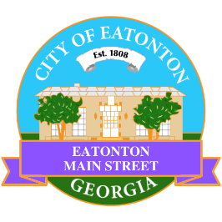

Eatonton Main Street
Advisory Board Meeting Agenda
October 14, 2025

Eatonton Main Street's Mission Statement:
To preserve and to enhance the historical and the cultural character of Eatonton through economic development.

Eatonton Main Street's Vision Statement:
Eatonton Main Street will be thriving and beautiful, rich in culture and heritage, sustained by community support.

- Call to Order

- Welcome
  - EQ Check-In
  - Approval of the Minutes from the September meeting
  - Financial Report

- Old Business
  - Review of the Workplan
  - Downtown Eatonton Farmer’s Market

- New Business
  - Future of An Evening in Eatonton
  - 2026 Annual Retreat
  - Manager Report
    - Walking Audit Results
    - Homework Assignment
    - Property Updates:
      - Smashin Burgers opened at 107 S. Oak Street
      - La Reine Belle closed at 108 N. Jefferson Ave. (space is available for $1,100/month)--?
      - Essential Bowls closed at 110 N. Jefferson Ave. (space is available for $1,500/month)--?
      - Make Fun Craft Club closed at 113 S. Jefferson Avenue
      - 125 S. Jefferson Avenue (the former Nina’s) is available for lease for $5,824/month
      - 321 S. Jefferson Avenue (the Dairy Building) is now $599,000, down from $679,000
      - 345 S. Jefferson Avenue is for sale for $179,000
- Façade Grants
  - Tipsy Turtle Bar & Grill

- Board News & Announcements
  - Lunch Break Day Party on Friday, October 24th from 11:00am until 1:00pm at the Eatonton City Center Stage; featuring The Hollywood Band
  - Rise & Shine…in Prime Time on Tuesday, October 28th at 6:30pm at El Catrin
  - Candy Mania on Friday, October 31st from 5:00pm until 8:00pm on N. Madison Avenue
  - SAVE THE DATE: Eatonton Mistletoe Market on Saturday, November 8th
  - SAVE THE DATE: Christmas in Eatonton on Saturday, December 13th

- Adjournment

Next Meeting: November 18, 2025 | 6:00pm | The Hut

