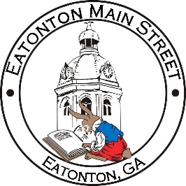

Eatonton Main Street
Advisory Board Meeting Agenda
July 13, 2021

Eatonton Main Street's Mission Statement:
To preserve and to enhance the historical and the cultural character of Eatonton through economic development.

Eatonton Main Street's Vision Statement:
Eatonton Main Street will be thriving and beautiful, rich in culture and heritage, sustained by community support.

- Call to Order

- Welcome
  - EQ Check-In
  - Approval of the Minutes from June Meeting
  - Financial Report
  - Team Exercise—Table Activity
  - Team Exercise—SWOT Analysis of Downtown Eatonton

- Old Business
  - None at this time

- New Business
  - Debrief of June & July Events

- Façade Grants
  - None at this time

- Board News & Announcements
  - Main Street 101 at www.GeorgiaMainStreet.org under “Training”
  - Downtown BASH on Thursday, July 29th at 5:30pm at the Artisans Village Art Gallery

- Adjournment

Next Meeting: August 10, 2021 | 6:00pm | The Hut

