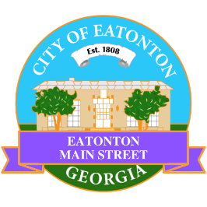

Eatonton Main Street
Advisory Board Retreat Agenda
January 14, 2025

Eatonton Main Street's Mission Statement:
To preserve and to enhance the historical and the cultural character of Eatonton through economic development.

Eatonton Main Street's Vision Statement:
Eatonton Main Street will be thriving and beautiful, rich in culture and heritage, sustained by community support.

- Call to Order

- Welcome
  - EQ Check-In
  - Approval of the Minutes from December Meeting
  - Financial Report

- Façade Grants
  - None at this time

- Annual Board Retreat

- Board News & Announcements
  - Upcoming schedule of Board Meetings
  - Later in January, the next Business Pop-Up and Rise & Shine Meeting
    - Date(s) TBA

- Adjournment

Next Meeting: February 11, 2025 | 6:00pm | The Hut

