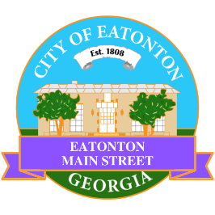

Eatonton Main Street
Advisory Board Meeting Agenda
September 15, 2022

Eatonton Main Street's Mission Statement:
To preserve and to enhance the historical and the cultural character of Eatonton through economic development.

Eatonton Main Street's Vision Statement:
Eatonton Main Street will be thriving and beautiful, rich in culture and heritage, sustained by community support.

- Call to Order

- Welcome
  - EQ Check-In
  - Approval of the Minutes from the August Meeting
  - Financial Report

- Old Business
  - Downtown Mural
  - Update on Wayfinding Signage

- New Business
  - New Board Officer
  - Manager Update
    - 2022-2023 Budget
    - 2023 Events
    - Property Updates

- Façade Grants
  - None at this time

- Board News & Announcements
  - Business Education Expo (BEE), Day 2 at the Chamber on Tuesday, September 20th from 6:00pm until 8:00pm
  - Registration deadline for the Scarecrow Contest is September 23rd
  - Rescheduled Downtown Open: A Mini Golf Event on Saturday, September 24th from 4:00pm until 8:00pm
  - Taste of Eatonton on Saturday, October 1st at The Plaza from 5:00pm until 9:00pm
- Adjournment

Next Meeting: October 11, 2022 | 6:00pm | The Hut

