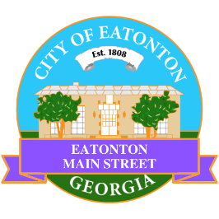

Eatonton Main Street
Advisory Board Meeting Agenda
March 10, 2026

Eatonton Main Street's Mission Statement:
To preserve and to enhance the historical and the cultural character of Eatonton through economic development.

Eatonton Main Street's Vision Statement:
Eatonton Main Street will be thriving and beautiful, rich in culture and heritage, sustained by community support.

- Call to Order

- Welcome
  - EQ Check-In
  - Approval of the Minutes from the February meeting
  - Financial Report

- Old Business
  - Review of the Workplan

- New Business
  - Clean-Up Day
  - Manager Report
    - March Events: Business Education Expo, An Evening in Eatonton, Farmer’s Market
    - Main Street Accreditation
    - Property Updates
      - 230 N. Jefferson Avenue sold for $30,000
      - Saving Grace Shop opened at 113 S. Jefferson Avenue
      - 112 S. Madison Avenue (the former Rice & Batchelor) is under contract; asking price is $432,000

- Façade Grants
  - None at this time

- Board News & Announcements
  - Business Education Expo (BEE) on Tuesday, March 17th at 6:00pm at the Chamber of Commerce
  - Next Accountability Call is Tuesday, March 24th at 6:30pm
  - An Evening in Eatonton is Thursday, March 26th from 5:00pm until 8:00pm
  - Downtown Eatonton Farmer’s Market is Friday, March 27th from 5:00pm until 8:00pm
  - Good Friday is Friday, April 4th. All City offices will be closed.
  - Magnolia Market & Chalk Walk is Saturday, April 11th from 10:00am until 3:00pm on the lawn of the Putnam County Courthouse. 2-3 volunteers will be needed to help load in vendors. 2 volunteers will be needed to help pull trashcans.
  - Field Trip to Downtown Lawrenceville is Tuesday, April 21st

- Adjournment

Next Meeting: April 14, 2026 | 6:00pm | The Hut

