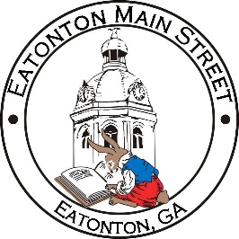

Eatonton Main Street
Advisory Board Meeting Agenda
May 11, 2021

Eatonton Main Street's Mission Statement:
To preserve and to enhance the historical and the cultural character of Eatonton through economic development.

Eatonton Main Street's Vision Statement:
Eatonton Main Street will be thriving and beautiful, rich in culture and heritage, sustained by community support.

- Call to Order

- Welcome
  - EQ Check-In
  - Team Exercise
  - Approval of the Minutes from April Meeting
  - Financial Report

- Old Business
  - Crosswalk Murals Update
  - Board Vacancy Update
  - Fundraising

- New Business
  - Arts & Entertainment District
  - Committee Updates

- Façade Grants
  - None at this time

- Board News & Announcements
  - Main Street 101 at www.GeorgiaMainStreet.org under “Training”
  - 0 Oconee Street is no longer under contract and for sale again.
  - Queen T’s Braid Haven has moved out of downtown.

- Adjournment

Next Meeting: Tuesday, June 8, 2021 | 6:00pm | The Hut

