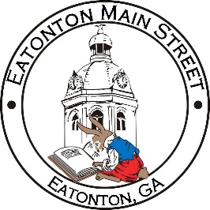

Eatonton Main Street
Advisory Board Meeting Agenda
May 10, 2022

Eatonton Main Street's Mission Statement:
To preserve and to enhance the historical and the cultural character of Eatonton through economic development.

Eatonton Main Street's Vision Statement:
Eatonton Main Street will be thriving and beautiful, rich in culture and heritage, sustained by community support.

- Call to Order

- Welcome
  - EQ Check-In
  - Approval of the Minutes from the April Meeting
  - Financial Report

- Old Business
  - Downtown Mural

- New Business
  - 2022-2023 Budget
  - Manager Update
    - Property Updates
    - Review of the Downtown BASH, Field Trip to Downtown McDonough, and the BBQ & Blues Festival

- Façade Grants
  - None at this time

- Board News & Announcements
  - Chamber of Commerce Ribbon Cutting for Tim Broyles State Farm on Friday, May 13th at 12:00pm
  - Downtown Eatonton Sidewalk Sale on Saturday, May 14th
  - Accountability Call on Tuesday, May 24th at 6:30pm
  - Dairy Festival on Saturday, June 4th
  - Makers & Movies on Saturday, June 11th featuring the movie “Soul”
- Adjournment

Next Meeting: May 10, 2022 | 6:00pm | The Hut

