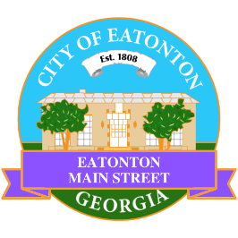

Eatonton Main Street
Advisory Board Meeting Agenda
November 14, 2023

Eatonton Main Street's Mission Statement:
To preserve and to enhance the historical and the cultural character of Eatonton through economic development.

Eatonton Main Street's Vision Statement:
Eatonton Main Street will be thriving and beautiful, rich in culture and heritage, sustained by community support.

- Call to Order

- Welcome
  - EQ Check-In
  - Approval of the Minutes from the October Meeting
  - Financial Report

- Old Business
  - Design Concept for S. Jefferson Ave./S. Oak Street
  - Update on Wayfinding Signage

- New Business
  - Grand Marshal for Christmas Parade
  - 2024 Board Officers
  - Review of 2023

- Façade Grants
  - None at this time.

- Board News & Announcements
  - Rescheduled Mistletoe Market on Saturday, November 18th from 10:00am until 3:00pm
    - Volunteers will be needed to help load in vendors from 7:45am until about 10:00am.
  - Thanksgiving is November 23rd.
  - Small Business Saturday is November 25th.
  - Christmas Parade is Saturday, December 9th at 1:00pm.
  - Christmas Parade After Party is Saturday, December 9th from 2:00pm until 5:00pm at the Stage
    - Volunteers will be needed on Saturday, December 9th for the parade and the After Party
      - 11:00am-1:00pm for the Parade (1-2 volunteers needed to line up the parade)
      - 10:30am-2:00pm for the After Party (3-4 volunteers needed to load in vendors)
  - Don’t forget about your required training: www.GeorgiaMainStreet.org
    - Main Street 101 is $75.
    - Switch to Six Webinar is free!
    - Deadline: December 31st
- Adjournment

Next Meeting: December 12, 2023 | 6:00pm | The Hut

