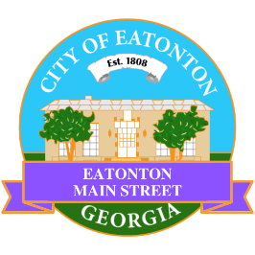

Eatonton Main Street
Advisory Board Meeting Agenda
October 8, 2024

Eatonton Main Street's Mission Statement:
To preserve and to enhance the historical and the cultural character of Eatonton through economic development.

Eatonton Main Street's Vision Statement:
Eatonton Main Street will be thriving and beautiful, rich in culture and heritage, sustained by community support.

- Call to Order

- Welcome
  - EQ Check-In
  - Approval of the Minutes from the September meeting
  - Financial Report

- Old Business
  - Review of the Workplan
  - Update on Business Visits
  - Agenda for Rise & Shine Meeting

- New Business
  - Best of Georgia Nomination
  - Christmas Lights
  - Manager Report
    - An Evening in Eatonton
    - Scarecrow Contest & Showcase
    - Homework Assignment
    - Property Updates
      - 108 & 110 N. Jefferson Avenue sold to Colonial State Holdings on September 30
      - Goldie & Co. closed on September 28
      - 109 N. Madison Avenue sold to Red Dog Creative
- Façade Grants
  - Colonial State Holdings

- Board News & Announcements
  - Business Pop-Up/Rise & Shine Meeting…In Prime Time will take place on Wednesday, October 16th at 5:30pm at El Catrin
    - No Accountability Call in October
  - Lunch Break Day Party will take place on Friday, October 25th from 11:00am until 1:00pm at the Eatonton City Center Stage
  - Eatonton Mistletoe Market will take place on Saturday, November 9th from 10:00am until 3:00pm
    - 4-5 volunteers will be needed to help load in vendors from 7:45am until 9:45am
    - 3-4 volunteers will be needed to help clean up and move trashcans from 2:30pm until 4:00pm
  - SAVE THE DATE: Christmas in Eatonton on Saturday, December 14th

- Adjournment

Next Meeting: November 12, 2024 | 6:00pm | The Hut

