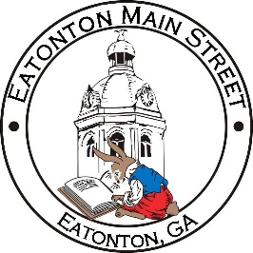

Eatonton Main Street
Advisory Board Meeting Agenda
April 12, 2022

Eatonton Main Street's Mission Statement:
To preserve and to enhance the historical and the cultural character of Eatonton through economic development.

Eatonton Main Street's Vision Statement:
Eatonton Main Street will be thriving and beautiful, rich in culture and heritage, sustained by community support.

- Call to Order

- Welcome
  - EQ Check-In
  - Approval of the Minutes from the March Meeting
  - Financial Report

- Old Business
  - Update on Downtown Benches
  - Downtown Mural

- New Business
  - Hart Family Fund for Small Towns
  - Manager Update
    - Dairy Festival
    - BBQ & Blues Festival Parking
    - Upcoming Events
    - Property Updates

- Façade Grants
  - None at this time

- Board News & Announcements
  - Magnolia Market & Chalk Walk on Saturday, April 16th from 10:00am until 3:00pm
    - Vendors will begin arriving at 8:00am.
    - S. Madison Avenue will be closed next to the old hotel.
  - City Council Meeting on Monday, April 18th at 7:00pm at the Putnam County Administration Building, Room 203
  - Downtown BASH on Tuesday, April 26th at 5:30pm; Location TBA
  - Accountability Call moved to Thursday, April 28th at 6:30pm due to the BASH
  - Field Trip to Downtown McDonough on Saturday, April 30th; Meet at City Hall at 8:30am
  - BBQ & Blues Festival on Saturday, May 7th from 2:00pm until 10:00pm at the Stage

- Adjournment

Next Meeting: May 10, 2022 | 6:00pm | The Hut

