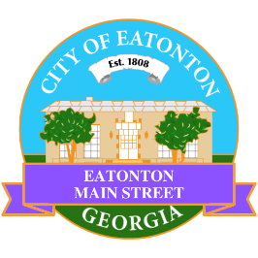

Eatonton Main Street
Advisory Board Meeting Agenda
December 12, 2023

Eatonton Main Street's Mission Statement:
To preserve and to enhance the historical and the cultural character of Eatonton through economic development.

Eatonton Main Street's Vision Statement:
Eatonton Main Street will be thriving and beautiful, rich in culture and heritage, sustained by community support.

- Call to Order

- Welcome
  - Welcome New Board Members
  - EQ Check-In
  - Approval of the Minutes from the November Meeting
  - Financial Report

- Old Business
  - HEART Squad

- New Business
  - 2024 Meeting Schedule
  - Rise & Shine Meeting
  - Manager Report
    - Mistletoe Market
    - Christmas Parade
    - Property Updates

- Façade Grants
  - Maggie Lane

- Board News & Announcements
  - Harmonious Notes unveiling at Butterflies & Blooms on Thursday, December 14th at 2:00pm
  - There will be no Accountability Call for the month of December.
  - Next Rise & Shine Meeting will take place in January.
  - Don’t forget about your required training: www.GeorgiaMainStreet.org
    - Main Street 101 is $75.
    - Switch to Six Webinar is free!
    - Deadline: December 31st
- Adjournment

Next Meeting: January 9, 2024 | 9:00am | Eatonton-Putnam Chamber of Commerce

