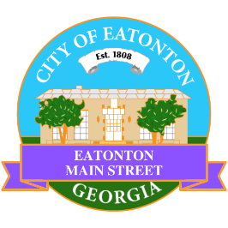

Eatonton Main Street
Advisory Board Retreat Agenda
January 16, 2026

Eatonton Main Street's Mission Statement:
To preserve and to enhance the historical and the cultural character of Eatonton through economic development.

Eatonton Main Street's Vision Statement:
Eatonton Main Street will be thriving and beautiful, rich in culture and heritage, sustained by community support.

- Call to Order

- Welcome
  - EQ Check-In
  - Approval of the Minutes from December Meeting
  - Financial Report

- Façade Grants
  - None at this time

- Annual Board Retreat
  - Review of Work Plan
  - Review of Survey Results
  - Creation of New Work Plan

- Board News & Announcements
  - None at this time

- Adjournment

Next Meeting: February 10, 2026 | 6:00pm | The Hut

