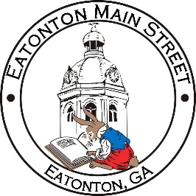

Eatonton Main Street
Advisory Board Meeting Agenda
October 12, 2021

Eatonton Main Street's Mission Statement:
To preserve and to enhance the historical and the cultural character of Eatonton through economic development.

Eatonton Main Street's Vision Statement:
Eatonton Main Street will be thriving and beautiful, rich in culture and heritage, sustained by community support.

- Call to Order

- Welcome
  - EQ Check-In
  - Approval of the Minutes from September Meeting
  - Financial Report

- Old Business
  - Update on Board Vacancy
  - Update on Main Street Logo

- New Business
  - Committees
  - 2022 Events
    - Downtown Art Projects
  - Manager Update
    - America’s Main Street Contest
    - Scarecrow Contest
    - Property Updates

- Façade Grants
  - Southern Delight Cafeteria

- Board News & Announcements
  - Main Street 101 at www.GeorgiaMainStreet.org under “Training” (Deadline: Oct. 31st)
  - Downtown BASH on Tuesday, October 26th from 5:30pm until 6:30pm at the Georgia Writers Museum, 109 S. Jefferson Avenue
  - Mistletoe Market on Saturday, November 13th—Volunteers will be needed.

- Adjournment

Next Meeting: November 9, 2021 | 6:00pm | The Hut

