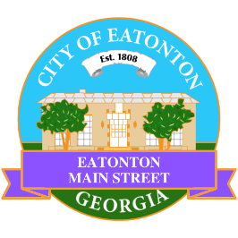

Eatonton Main Street
Advisory Board Meeting Agenda
February 14, 2023

Eatonton Main Street's Mission Statement:
To preserve and to enhance the historical and the cultural character of Eatonton through economic development.

Eatonton Main Street's Vision Statement:
Eatonton Main Street will be thriving and beautiful, rich in culture and heritage, sustained by community support.

- Call to Order

- Welcome
  - EQ Check-In
  - Approval of the Minutes from the January Meeting
  - Financial Report

- Old Business
  - Update on Board Vacancies
  - Update on Wayfinding Signage
  - Update on Downtown Mural

- New Business
  - Next Rise & Shine Meeting
  - 2023 Required Training
  - Manager Report:
    - #LoveLocal Letters
    - Property Updates
    - Accreditation Update

- Façade Grants
  - None at this time

- Board News & Announcements
  - Next Accountability Call on Tuesday February 28th at 6:30pm
  - Lumberjaxe Ribbon Cutting & Grand Opening on Wednesday, March 1st at 4:00pm
  - Seuss on the Loose on March 4th
  - Business Education Expo at the Chamber of Commerce on March 21st at 6:00pm
- Adjournment

Next Meeting: March 14, 2023 | 6:00pm | The Hut

