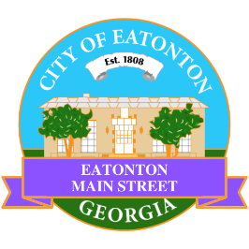

Eatonton Main Street
Advisory Board Meeting Agenda
September 10, 2024

Eatonton Main Street's Mission Statement:
To preserve and to enhance the historical and the cultural character of Eatonton through economic development.

Eatonton Main Street's Vision Statement:
Eatonton Main Street will be thriving and beautiful, rich in culture and heritage, sustained by community support.

- Call to Order

- Welcome
  - EQ Check-In
  - Approval of the Minutes from the August meeting
  - Financial Report

- Old Business
  - Review of the Workplan
  - Update on Business Visits
    - Business Pop-Up
  - The Eatonton Expedition

- New Business
  - 2024-2025 Budget
  - 2024-2025 Events
  - Manager Report
    - CREATE Program
    - Upcoming events: An Evening in Eatonton & Scarecrow Contest & Showcase
    - Property Updates
      - 108 & 110 N. Jefferson Avenue is scheduled to close on Friday, September 13th
      - 125 S. Jefferson Avenue (formerly Nina’s Beauty Supply) is for sale for $400,000
      - 200 Oak Street (formerly A-1 Action Cash Title Pawn) is for rent for $2,000/month
      - 119 N. Jefferson Avenue (formerly The Rabbit’s Hole) is for rent
- Façade Grants
  - Dr. Meigan Miller Family Dentistry

- Board News & Announcements
  - Next Downtown GetDown Concert will take place on Saturday, September 14th with Cash’s Juke Joint
    - 1 volunteer to help with band hospitality from 5:00pm-7:30pm
  - Next Accountability Call is Tuesday, September 24th at 6:30pm
  - An Evening in Eatonton is Thursday, September 26th from 5:00pm until 8:00pm
  - SAVE THE DATE: Eatonton Mistletoe Market on Saturday, November 9th
  - SAVE THE DATE: Christmas in Eatonton on Saturday, December 14th

- Adjournment

Next Meeting: October 8, 2024 | 6:00pm | The Hut

