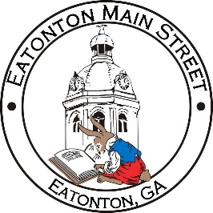

Eatonton Main Street
Advisory Board Meeting Agenda
April 13, 2021

Eatonton Main Street's Mission Statement:
To preserve and to enhance the historical and the cultural character of Eatonton through economic development.

Eatonton Main Street's Vision Statement:
Eatonton Main Street will be thriving and beautiful, rich in culture and heritage, sustained by community support.

- Call to Order

- Welcome
  - EQ Check-In
  - Team Exercise
  - Approval of the Minutes from March Meeting
  - Financial Report

- Old Business
  - Crosswalk Murals Update
  - Board Vacancy Update

- New Business
  - Committee Updates
  - Proposed Budget for 2021-2022
  - Fundraising

- Façade Grants
  - None at this time

- Board News & Announcements
  - Main Street 101 at www.GeorgiaMainStreet.org under “Training”
  - 113 E. Marion Street is under contract.
  - 0 Oconee Street is under contract.
  - 101 Oak Street has been leased.
  - Downtown BASH on April 27th at 5:30pm
  - Downtown Sidewalk Sale on May 8th

- Adjournment

Next Meeting: Tuesday, May 11, 2021 | 6:00pm | The Hut

