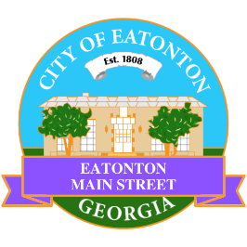

Eatonton Main Street
Advisory Board Meeting Agenda
June 13, 2023

Eatonton Main Street's Mission Statement:
To preserve and to enhance the historical and the cultural character of Eatonton through economic development.

Eatonton Main Street's Vision Statement:
Eatonton Main Street will be thriving and beautiful, rich in culture and heritage, sustained by community support.

- Call to Order

- Welcome
  - EQ Check-In
  - Approval of the Minutes from the May Meeting
  - Financial Report
  - SWOT Analysis

- Old Business
  - El Cazador Mexican Restaurant

- New Business
  - Hype Team
  - Manager Report:
    - Dairy Festival
    - Downtown GetDown Concert Series
    - Property Update
      - 113 N. Jefferson Avenue is for sale for $1,350,000
      - Colonial Armament is scheduled to open on July 1st at 111 N. Jefferson Avenue
      - Kina’s Krazy Kreations opened at 107 S. Oak Street
      - The Affordable Housing Coalition Outlet Center/Eatonton Business Incubator opened at 202 N. Jefferson Avenue, Suite C
      - The Blackwell House (201 N. Madison Avenue) is for sale for $849,000 (down from $1.1 million)
      - The Ezell House (300 N. Madison Avenue) is for sale for $799,900

- Façade Grants
  - None at this time

- Board News & Announcements
  - Rise & Shine in Primetime is Tuesday, June 27th at 6:30pm at Lumberjaxe
  - Downtown GetDown Concert Series is July 8th; Vendors open at 6:00pm, Concert at 7:00pm
  - Don’t forget about your required training: www.GeorgiaMainStreet.org
    - Main Street 101 is $75.
    - Switch to Six Webinar is free!
- Adjournment

Next Meeting: July 11, 2023 | 6:00pm | The Hut

