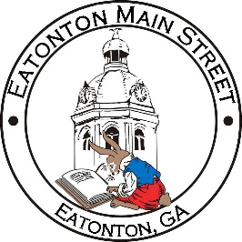

Eatonton Main Street
Advisory Board Meeting Agenda
December 14, 2021

Eatonton Main Street's Mission Statement:
To preserve and to enhance the historical and the cultural character of Eatonton through economic development.

Eatonton Main Street's Vision Statement:
Eatonton Main Street will be thriving and beautiful, rich in culture and heritage, sustained by community support.

- Call to Order

- Welcome
  - EQ Check-In
  - Team Exercise
  - Approval of the Minutes from November Meeting
  - Financial Report

- Old Business
  - Update on Main Street Logo
  - Review of Rise & Shine Meeting

- New Business
  - 2022 Meeting Schedule
  - Review of 2021

- Façade Grants
  - None at this time.

- Board News & Announcements
  - None at this time

- Adjournment

Next Meeting: January 11, 2022 | 9:00am-2:00pm | Chamber of Commerce

