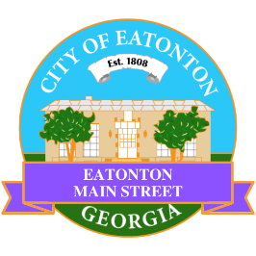

Eatonton Main Street
Advisory Board Meeting Agenda
September 12, 2023

Eatonton Main Street's Mission Statement:
To preserve and to enhance the historical and the cultural character of Eatonton through economic development.

Eatonton Main Street's Vision Statement:
Eatonton Main Street will be thriving and beautiful, rich in culture and heritage, sustained by community support.

- Call to Order

- Welcome
  - EQ Check-In
  - Approval of the Minutes from the August Meeting
  - Financial Report

- Old Business
  - Hype Team
  - Visits to Downtown Businesses
    - Scarecrow Contest

- New Business
  - Advisory Board Terms
  - Manager Report:
    - Hispanic Heritage Month
    - Mistletoe Market
    - Property Update

- Façade Grants
  - Colonial Armament
  - Taylor Event & Floral Design

- Board News & Announcements
  - Dancing in Downtown from 6:30pm until 8:00pm at the Eatonton City Center Stage:
    - September 18—Bachata
    - September 25—Merengue
    - October 2—Salsa
    - October 5—Review
  - ¡Bailamos! On Saturday, October 14th from 4:00pm until 7:00pm at the Eatonton City Center Stage
  - Don’t forget about your required training: www.GeorgiaMainStreet.org
    - Main Street 101 is $75.
    - Switch to Six Webinar is free!
- Adjournment

Next Meeting: October 10, 2023 | 6:00pm | The Hut

