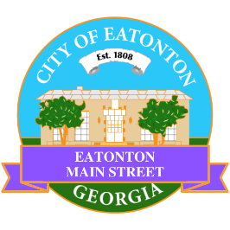

Eatonton Main Street
Advisory Board Meeting Agenda
November 12, 2024

Eatonton Main Street's Mission Statement:
To preserve and to enhance the historical and the cultural character of Eatonton through economic development.

Eatonton Main Street's Vision Statement:
Eatonton Main Street will be thriving and beautiful, rich in culture and heritage, sustained by community support.

- Call to Order

- Welcome
  - EQ Check-In
  - Approval of the Minutes from the October meeting
  - Financial Report

- Old Business
  - Review of the Workplan
  - Update on Business Visits
  - Review of the Rise & Shine Meeting

- New Business
  - Manager Report
    - National Main Street Conference
    - Property Updates
      - 110 N. Jefferson Avenue has been leased to Essential Bowls; Opening date TBA
      - Salty Claw Seafood Kitchen opened at 107 S. Oak Street
      - El Cazador’s alcohol license
      - 109 N. Madison Avenue is under renovation by Red Dog Creative
  - Christmas Parade Grand Marshal
  - Main Street Community Self-Assessment Tool

- Façade Grants
  - Georgia Writers Museum (113 N. Jefferson Avenue)
  - Papa Johns Pizza
  - El Cazador Mexican Restaurant

- Board News & Announcements
  - Due to the holidays, there will no Accountability Calls in November and December
  - “A Christmas Evening in Eatonton” on Thursday, December 5th from 5:00pm until 8:00pm
    - 1-2 volunteers will be needed to assist with the carriage rides
  - Best of Georgia results will be announced on December 6th
  - Christmas in Eatonton on Saturday, December 14th from 4:00pm until 9:00pm
    - 2-3 volunteers will be needed to help load in vendors from 1:45pm until 3:45pm
    - Parade steps off at 6:00pm
    - 1-2 volunteers will be needed to help line up the Parade entries from 4:00pm-6:00pm

- Adjournment

Next Meeting: December 10, 2024 | 6:00pm | The Hut

