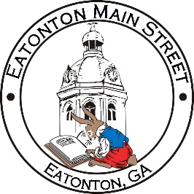

Eatonton Main Street
Advisory Board Meeting Agenda
February 8, 2022

Eatonton Main Street's Mission Statement:
To preserve and to enhance the historical and the cultural character of Eatonton through economic development.

Eatonton Main Street's Vision Statement:
Eatonton Main Street will be thriving and beautiful, rich in culture and heritage, sustained by community support.

- Call to Order

- Welcome
  - EQ Check-In
  - Approval of the Minutes from January Meeting
  - Financial Report

- Old Business
  - Update on Main Street Logo
  - Update on Nails By Aaron

- New Business
  - Focus on Committees
  - Manager Update
    - #LoveLocal Letters
    - Property Updates

- Façade Grants
  - None at this time.

- Board News & Announcements
  - Accountability Call on February 22nd
  - Seuss on the Loose on March 5th at the Primary School
  - Business Education Expo (BEE) on March 15th and March 22nd at the Chamber

- Adjournment

Next Meeting: March 8, 2022 | 6:00pm | The Hut

